EV3 Basic:

There are two files in the compressed file, including a .jpg and .pklg.
For my mac, the default application to open .pklg file is wireshark, although I haven’t seen this file extension before. The .jpg is shown what the EV3 looks like.
After taking a look, the .pklg file format is similar to pcap or pcapng. In the file, there are timestamp, source/destination (which are characterized as either controller or host), protocol (PKTLOG, HCI*, L2CAP…), length and info sections.

I sorted the source/destination, protocols, and info sections sequentially.

Find out that, with sorting by source, in localhost section:
No. 289, 299, 309…etc showing something interested: hi}
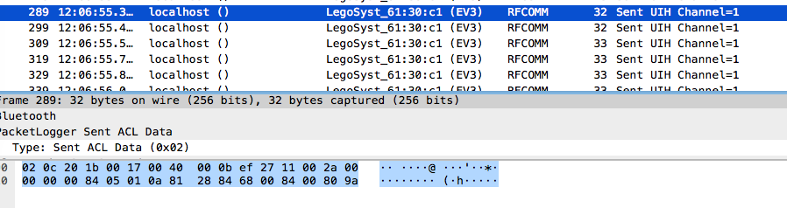
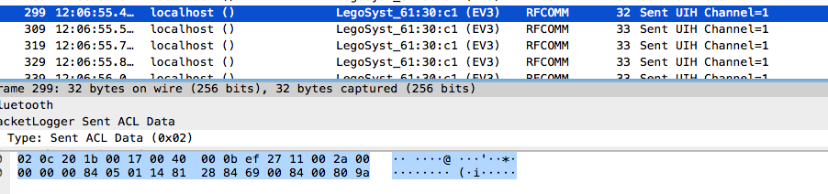
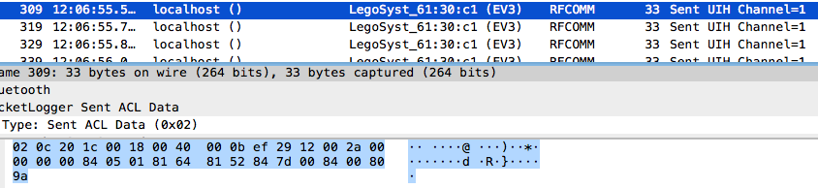

This looks like the beginning and ending of the flag: hixxxxxxxxxxxx}

But, that didn’t make any sense to me since there were bunches of letters missing in the session.

At first, I just noticed that I should take two parameters into consideration for a packet rather than one character. That is: (h, (I, R) etc.
So the result would be:
( h I { 1 n c d o t …
R } …
D e …
6 a

However, that’s still not make sense to me. Based on this order, I cannot get a flag. So I study the packet again and draw, comparing the changing things in different but related packets:
No. | Parameter1  (might be group) | Parameter2  (might be flag) | Changing bit  (hex=decimal)
289 | ( | H | 0a = 10
299 | ( | i | 14 = 20
309 | R | }
319 | ( | { | 46 = 70
329 | ( | 1 | 5a = 90
339 | ( | n | 3c = 60
349 | D | e
359 | ( | c | 28 = 40
389 | ( | t | 1e = 30
Keep filling the form
Compose: (use the changing bit number as the order from small to big)
Ex:
10-h
20-hi
30-hit
40-hitc
then I get the flag: hitcon{m1nd5t0rm_communication_and_firmware_developer_kit}

